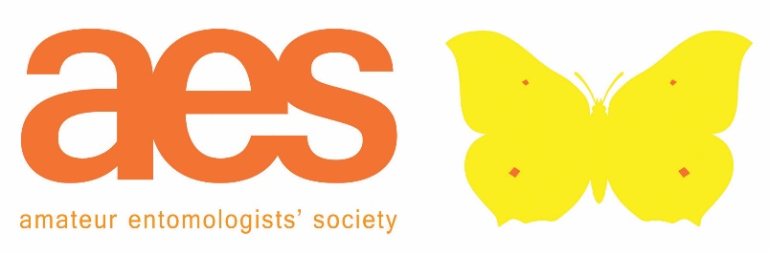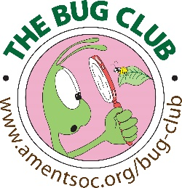

Registered Charity No. 267430

Annual Report to Members
Year ended 31 December 2020

Dear Member,

The society had another successful year in 2020 despite the Covid-19 pandemic, which required us to not hold any in-person events. The production of our journals and newsletters was largely unaffected, and our membership services and online shop continued to operate as before.

A third edition of the book A Guide to Moth Traps and their Use was produced, edited by Dr Paul Waring. We also published an AES edition of the children’s book Crystal the Small Miracle, by Sonia Bloom, thereby completing our set of six such publications for young children. The title was previously published by the charity Butterfly Conservation.

AES Council member Dr Malcolm Aldridge had preliminary discussions with the Royal Entomological Society regarding how our two societies might continue our cooperation for the benefit of entomology in future, and an affiliations subcommittee was established. A sign of the times: a team was established to explore audio-visual content, and an AES YouTube channel was set up.

Our Conservation Committee continued to participate in external committees and to keep the trustees informed of developments, such as for example the preliminary proposals for the quinquennial review of schedules 5 and 8 of the Wildlife and Countryside Act 1981. Our Invertebrate Conservation News has for some time now been made available in electronic form to members of the British Entomological Society, without charge. We continued to respond to government consultations; for example, Dr David Lonsdale submitted comments consistent with the Society’s written conservation policy on the proposed planning legislation in England, on behalf of the Society. A copy of his comments was posted on the AES website.

Perhaps not surprisingly, we experienced a decline in member numbers during the calendar year, to 965 entomologists. This number can be accounted for by around 250 members not renewing in 2020, offset by 166 new members, of whom 75 joined the Bug Club. Approximately one-fifth of our members and affiliates receive the Bug Club Magazine.

Those new members who heard about our society online were the most numerous, but it is heartening that a significant minority of 7.2% heard about us by word of mouth. Among our 100 or so ‘overseas’ members the majority were based in the United states, and a significant proportion of those are Bug Club members. Online conferencing technology will, usefully, allow overseas members to join our future online events and resources.

Our Annual General Meeting was held on 17th October using Zoom technology (please see separate AGM Minutes) and was followed by an interesting talk by our President, Dr Erica McAlister, on the anatomy of flies and how that knowledge has influenced human inventions.

Awards 2020
The Annual Exhibition did not take place this year, and therefore the following awards were not conferred: the Bernard Skinner Award for excellence in entomology; the Bradford Award (best exhibit at the Annual Exhibition); the Ansorge Award (best junior exhibits)

The Hammond Award [Best article on British insects in the AES Bulletin during the year] was awarded to Dr Peter Sutton.

The Gardiner Award [for contributions to the Bug Club Magazine] was awarded to the following: Benjamin Gubb; Thomas Porter; Lily Reece; Aidan Scott.

Governance
AES Council met in person in February 2020, and subsequently, on-line in September and November, with decisions taken in-between those meetings being recorded in a separate document in lieu of Minutes. Further, it was decided that it would be in the interests of the Society and its members to hold all future Council meetings online, with the exception of one in-person meeting each year.

Deaths
Finally, it is with much sadness that we mark the passing of the following members of the Society, as notified to us since the last AGM:

Jenny Coulson (8106) of Bourgogne, France
Dr Hewett Ellis (9940) of North Shields, Tyne and Wear
Anthony M. V. Hoare (7295) of Leatherhead, Surrey

Financial Summary
Substantial annual donations from both the British Entomological and Natural History Society and from an anonymous donor, in support of the Bug Club, helped ensure that we were in the black at the end of the financial year. We also received £900 from the sale of a cabinet that was kindly donated to the society in memory of Gerald White, of Leicester.

Receipts for the year were £39,648 (2019: £55,296) and expenses paid out were £38,632 (2019: £60,618). Both receipts and expenses were significantly lower than the previous year due to the impact of the Covid-19 pandemic which prevented the holding of our annual exhibition and other events. Despite this our income held up well, although there has been a fall in membership numbers. We were also able to make cost savings by holding meetings on-line. We ended the year with an overall surplus of £1,016 which will help us in future.

Our small investment portfolio exists purely to underwrite our future and to provide a small ‘buffer’ against any fluctuations in income and expenditure. The market value of this portfolio on 31st December 2020 was £140,787 (2019: £145,267). During the year the value of this portfolio was affected by the significant fall in the Stock Market due to the pandemic, but recovered along with the Market to be only 3% lower than the previous year’s value. The dividends on our investments were down 15% compared with the previous year but we anticipate improved returns as the Stock Market and economy recover. However, the dividends on our investments, and their capital value at year end, will of course vary with the market.

Dafydd Lewis (Hon. Secretary)
Peter Brown (Hon. Treasurer)
1st August 2021

