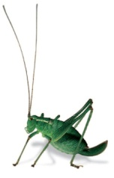
AES ANNUAL EXHIBITION 2022

Dear Member,

We would like to invite you to exhibit at the 2022 Annual Exhibition at Kempton Park Racecourse on Saturday 1st October 2022

Member exhibits

An integral part of the exhibition is the members’ exhibits area, and we have seen a small increase in the numbers of exhibits being put together by our members over the past few years (well, up to the pandemic, anyway)! We would like to remind members that there are prizes available for the exhibits that are judged to be best in each class. Prizes are announced at around 2pm, but exhibitors are asked to keep their exhibits in place until the end of the exhibition, for all to enjoy.

We welcome all exhibits, no matter how large or small, and remind members that insects that are common in some areas are rare in others. All members that put forward an exhibit are automatically entered for one of a number of cash prizes, with £100 available to the best exhibit in each category. The Bradford Award is presented to the best adult exhibit and the Ansorge Bequest allows us to give cash prizes to Bug Club and other young members in various age categories.

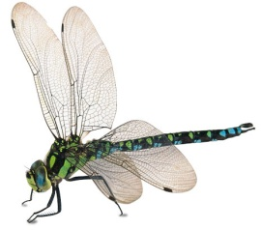
To help ensure that we have adequate space, and that you gain entry on the day, you should let us know in advance, wherever possible! A special pass is allocated per exhibit to allow free entry into the exhibition halls from 10.30am to set up your exhibit. For junior members, an additional pass is allocated for an adult to accompany the exhibitor. Due to health and safety, we are not able to allocate any further passes or to allow entry before 10.30am. The exhibition opens at 11am to the public.

We would also appreciate a short note and photographs to accompany your exhibit, which will then be published in the Bulletin.

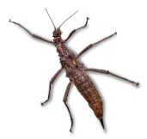
Please do take the time to consider submitting an entry to the exhibition this year. We are keen to promote this aspect of the exhibition and all entries, large or small will be very welcome.

Nick Wadham
AES Exhibition Secretary

Application Form for Member Exhibit at the AES Exhibition
Saturday 1st October 2022, Kempton Park Racecourse

Name ……………………………………………………………..……….…………. Membership No …………..……………

Address …………………………………………………………………………………………………………………………………….

………………………………………………………………………………………………………………………………………………….

Telephone …………………………………………….. Email ……………………………………………………………………….

Exhibit Space
(There is no charge for exhibit space – one free pass is issued per adult exhibit and two passes for a junior exhibitor. Pass allows entry to the halls from 10.30am)

I will be exhibiting as a… Please tick
Junior Member* |  | *Please give age on 30/09/22
Adult Member

I shall require approximately | m | of table space.

I shall be exhibiting :

I shall / shall not* require an electricity supply. (*Please delete as appropriate)

PLEASE COMPLETE AND RETURN THIS FORM TO: exhibition@amentsoc.org
(Or by post to PO Box 8774, London SW7 5ZG)

Please do provide a short article about your exhibit for publication in the Bulletin. We would welcome pictures to accompany your article. Please email your report to exhibition@amentsoc.org or hand in a copy at the reception desk at the show.

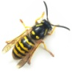
Exhibits should be in place by 11am and should not be removed until the exhibition closes. Whilst every effort is made to ensure that your exhibit will be monitored during the day by the stewarding team, the Society cannot be held responsible for any exhibits that are left unattended.

Please note – the Society does not welcome long series of rare or endangered species and exhibits of this nature shall not be allowed.

